AI Assistant Lab
Assignment 4.4
NAME: K.UMA MAHESHWARI
HALL: 2303A52430
BATCH: 44
1. Sentiment Classification for Customer Reviews.
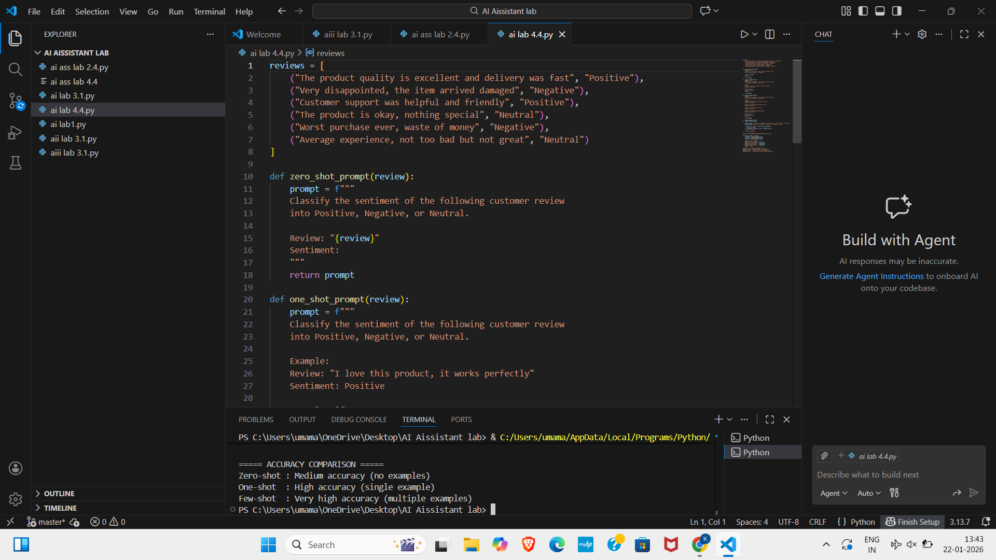
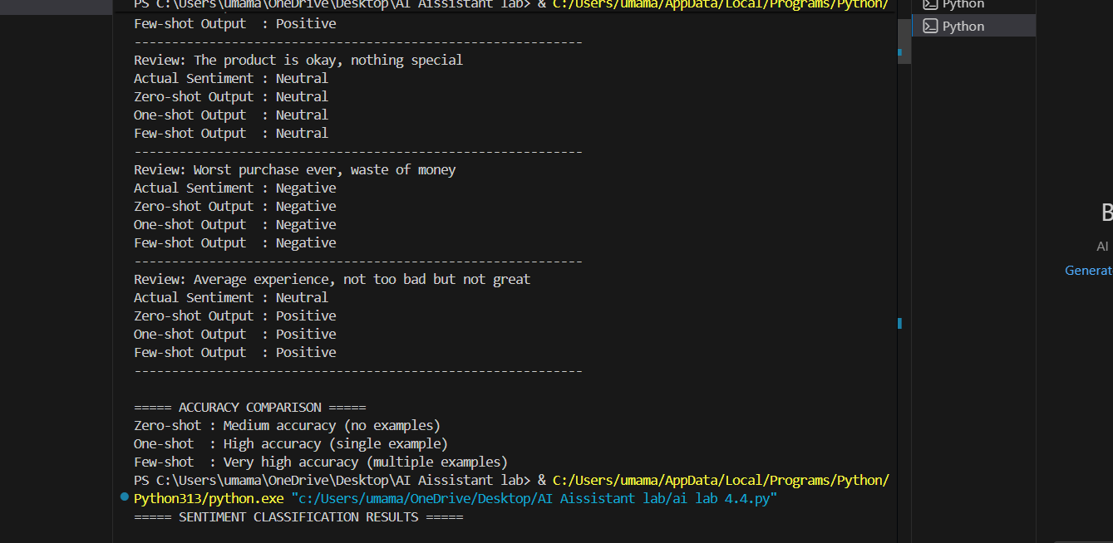
TASK 2: Email Priority Classification

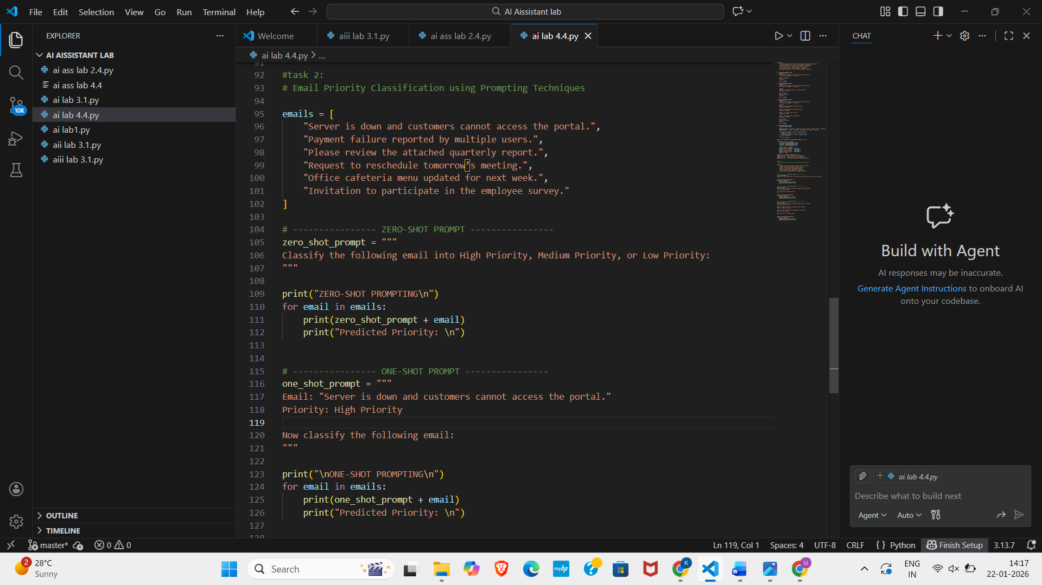
Output:
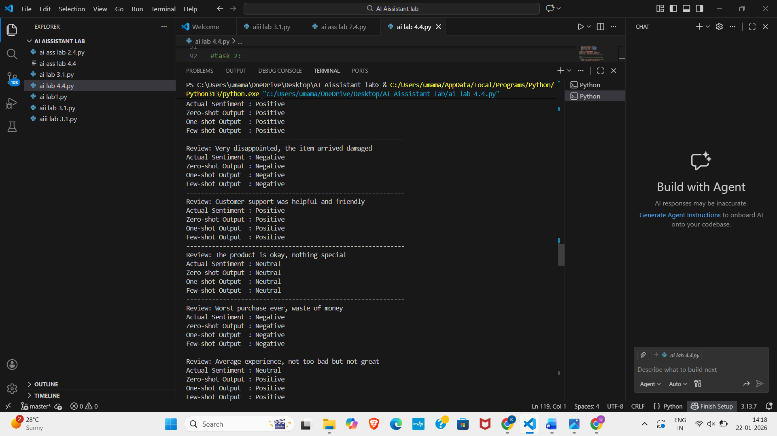

TASK 3: Student Query Routing System
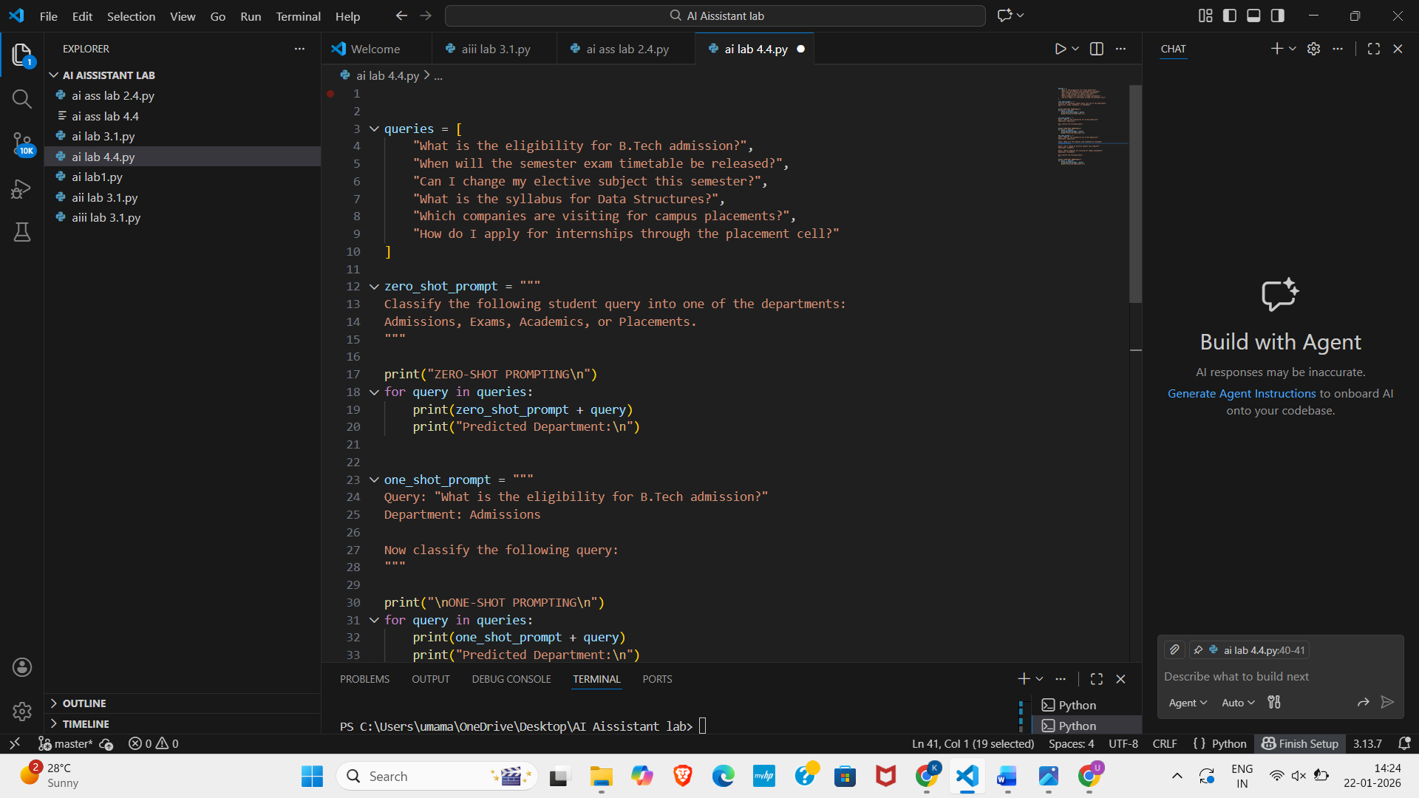
Output:
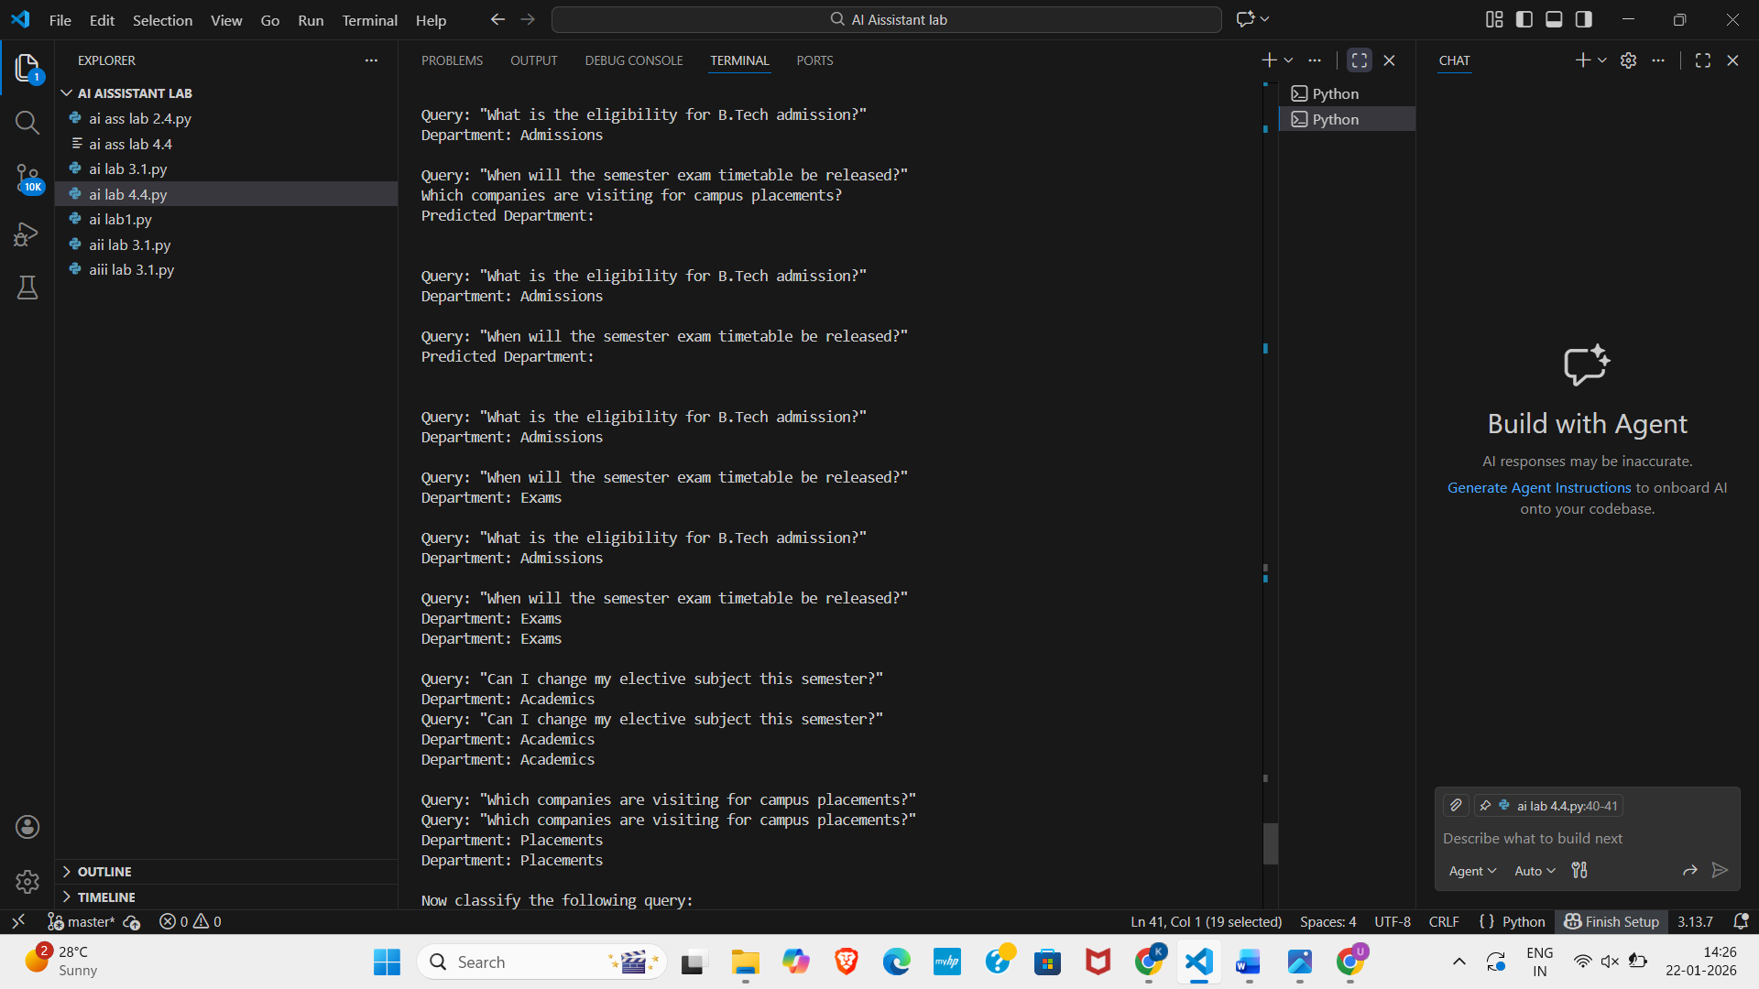
4. Chatbot Question Type Detection:
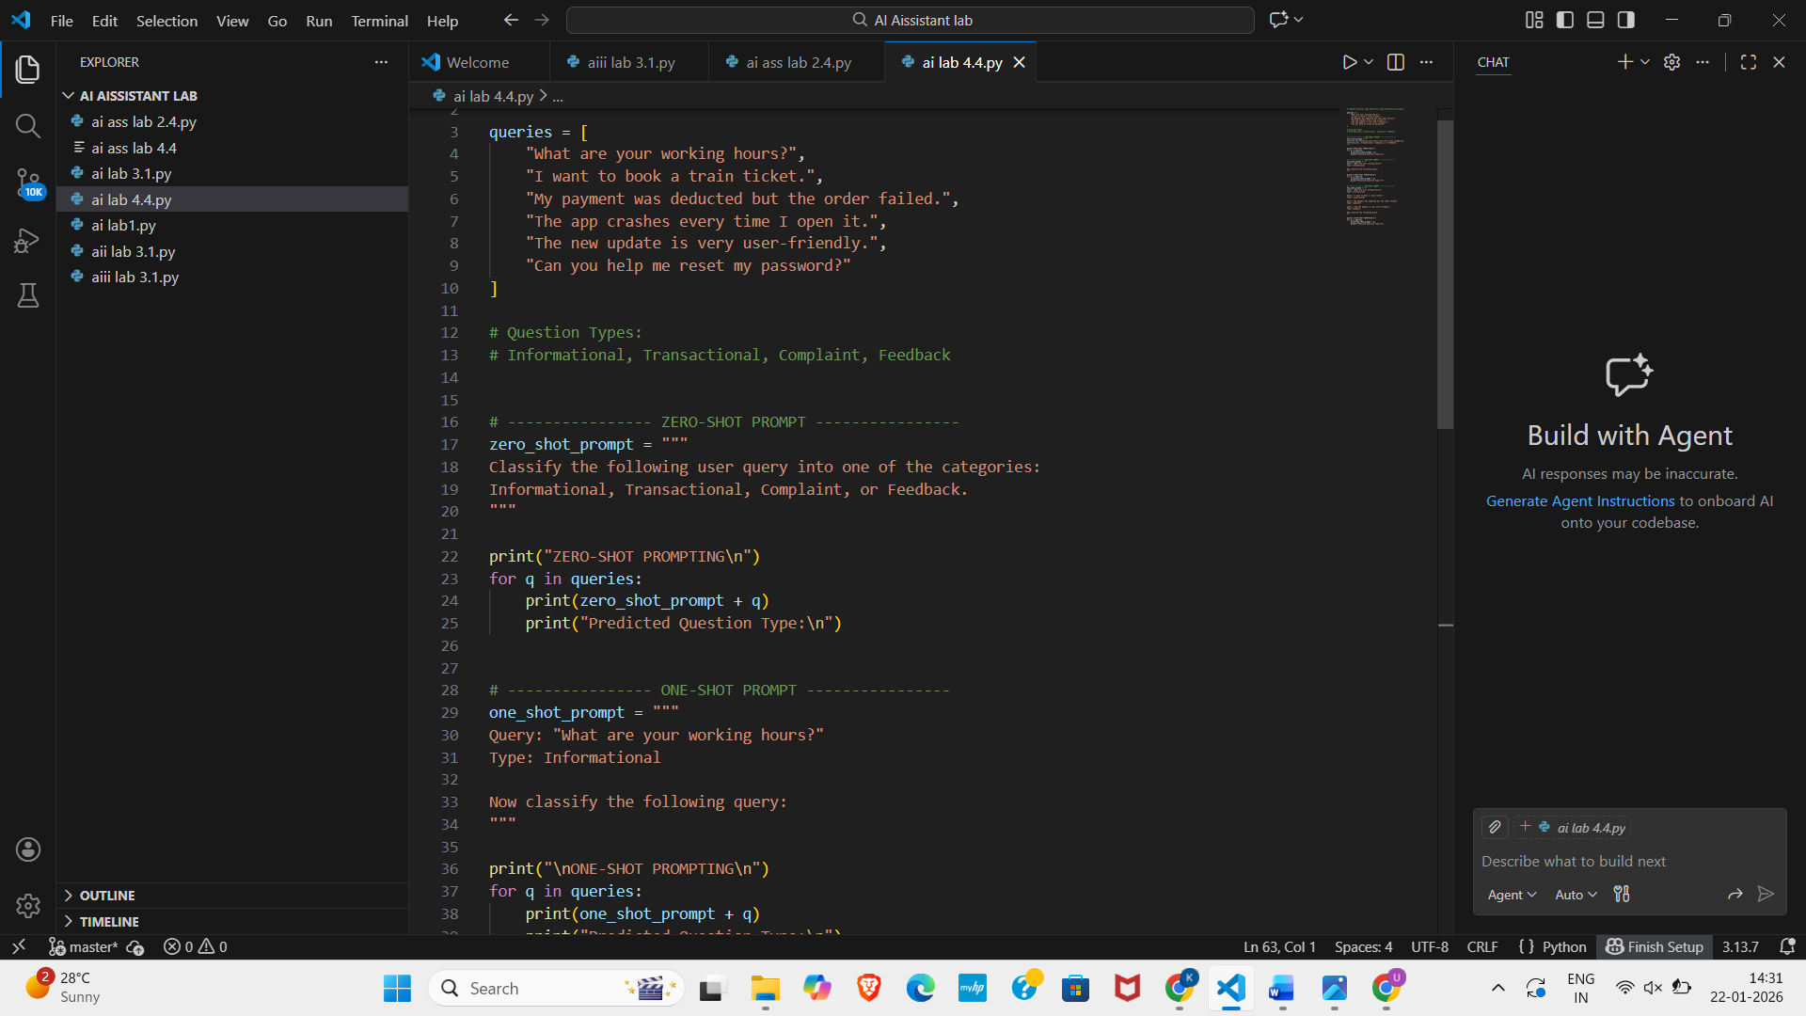
Output:
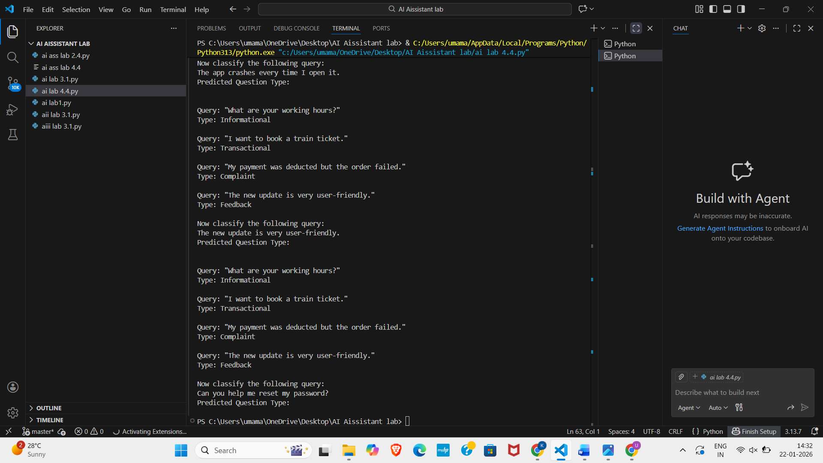
5. Emotion Detection in Text.
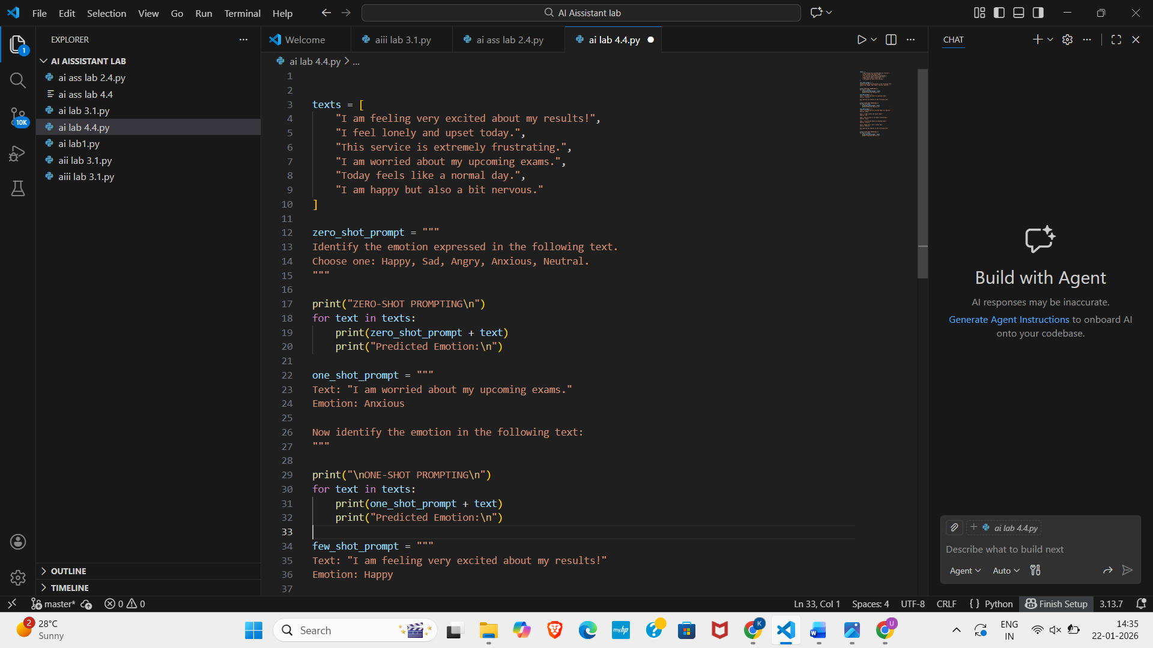
Output:
